While analyzing voice data from both Glassdoor and YouTube, clear differences in tone, structure, and insight emerged despite overlapping themes. Glassdoor reviews are more structured and constructive, often outlining pros, cons, and actionable feedback for management, making it easier to identify patterns and assess sentiment with clarity. In contrast, YouTube content is more emotionally driven and less structured, suggesting employees feel more open to expressing unfiltered experiences. Although this makes themes slightly harder to extract, it provides deeper context into day-to-day operations, work pace, and work-life balance challenges. Together, these platforms complement each other—Glassdoor offering clarity and direction, while YouTube provides depth and lived experience.

Glassdoor Keyword Cloud
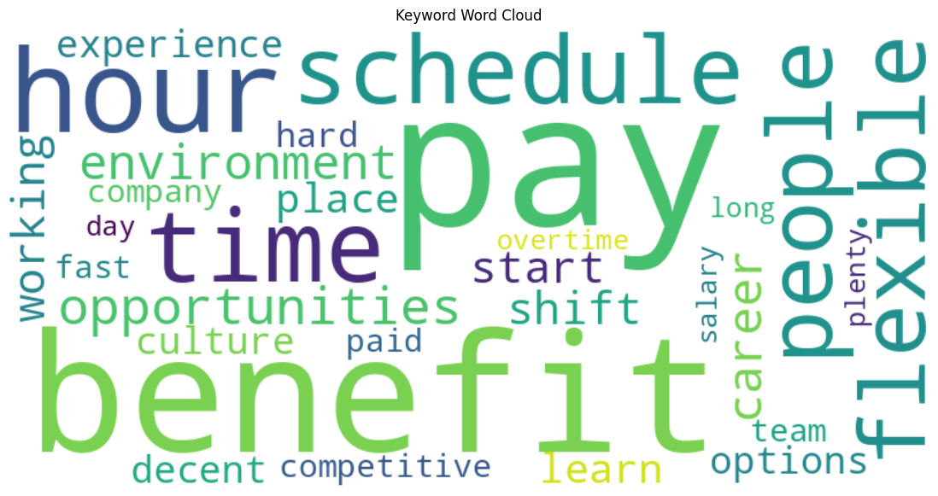

YouTube Keyword Cloud
